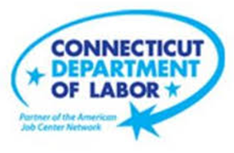

**NEW WEEKLY JOB POSTINGS FROM   
HELP WANTED ONLINE  
Office of Research**

**Week Ending January 7th, 2023: New Ads Rebound from Late of December Dip**WETHERSFIELD, January 13th, 2022 – During the week ending January 7th, there were 5,991 new postings, up 2,265 or +61% over the week. This over-the-week increase of 2,265 new ads follows a 2,460 new ad drop the week before. The graph below shows how statewide new ads dipped a week ago and have rebounded to within 7% of levels from two weeks ago. The graph also shows a more pronounced end-of-December dip at the end of 2021. Four industries accounted for half of the overall increase during the week ending January 7th, 2023. These include Healthcare & Social Assistance (+457 new ads), Retail Trade (+177 new ads), Finance & Insurance (+263 new ads), and Manufacturing (-234 new ads). Employers with the largest over-the-week increases include Hartford Healthcare (+138 new ads), Cigna (+55 new ads), and Raytheon (+43 new ads). Excluding the new ad drop to 3,726 during the last week of December, total new ads have ranged between 5,700 to 6,800 since late November.  
  
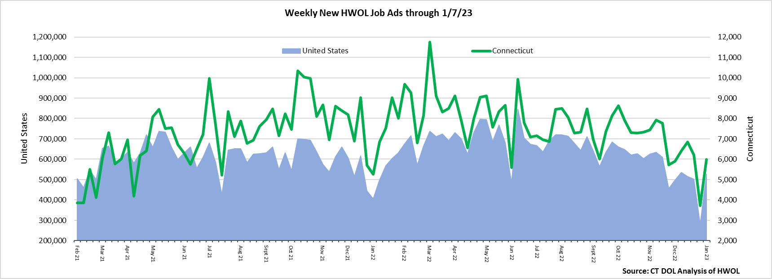  
**Industries** with the most new postings include Health Care & Social Assistance, Finance & Insurance, and Manufacturing.

**Occupations** with the most new postings include Registered Nurses, Retail Salespersons, and Supervisors of Retail Sales Workers.

**Employers** with the most new postings include Hartford Healthcare, Community Health Center Inc., and St. Francis Health System.

**The three industries with the most new job postings were:**

* **Health Care & Social Assistance** (1,626 new postings, +39% over the week)
* **Finance & Insurance** (509 new postings, +107% over the week)
* **Manufacturing** (449 new postings, +109% over the week)

   
 During the week ending January 7th, 2023, the 61% new ad total increase is the net result of increases in 19 of 21 industries. Most industries had over-the-week gains of 50% or more, as overall ad levels returned to levels from two weeks ago when there were 6,410 total new ads. The largest over-the-week employer increases among the four industries with the largest new ad change include Hartford Healthcare (+138 new ads) in Health Care & Social Assistance, CVS Health (+26 new ads) in Retail Trade, Cigna (+48 new ads) in Finance & Insurance, and Raytheon (+43 new ads) in Manufacturing. Compared to four weeks ago, total ads are down 7% or -419 new ads, and 14 of 21 industries had four-week declines, the largest being Manufacturing (-124 new ads) and Professional, Scientific, & Technical Services (-110 new ads). The largest four-week increase occurred in Accommodation & Food Services (+132 new ads).   
  
 For more information on total job ads by industry for Connecticut and its labor market areas, see the monthly report available here: <https://www1.ctdol.state.ct.us/lmi/hwol.asp>

**New Job Postings by Occupation** 

**The occupations with the most new postings were:**

* Registered Nurses (473 new postings, +56% over the week)
* Retail Salespersons (174 new postings, +36% over the week)
* Supervisors of Retail Sales Workers (154 new postings, +77% over the week)

**Employers with the Most New Job Postings** Employers with the most new job postings during the week were mostly within Health Care & Social Assistance, Retail Trade, and Finance & Insurance. The 25 employers shown above account for 17 percent of all new ads. 22 employers in the top 25 increased over the week and 3 decreased. Within the 25 largest employers, the largest increase occurred at Hartford Healthcare (+138 new ads) and the largest decrease occurred at Community Health Center, Inc. (-137 new ads).  
  
**What is HWOL?**The **Conference Board Help Wanted Online**® Data Series (HWOL) measures the number of new, first-time Online job postings and jobs reposted from the previous month for over 16,000 Internet job boards, corporate boards, and smaller job sites that serve niche markets and smaller geographic areas. To view more HWOL data, go to: <https://www1.ctdol.state.ct.us/lmi/hwol.asp>